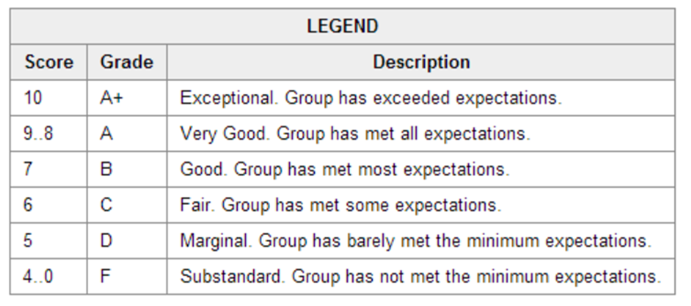Deliverable 3 New Systems User Interface - Evaluation

Due:

Students:

|  |  |  |  |
| --- | --- | --- | --- |
| **Sections** | **Weight** | **Score** | **Weighted**  **Score** |
| **Submission Quality** – professional, complete, accurate, readable, correct spelling/grammar/sentence structure, completed using a diagraming tool, includes a proper title page with required information, indicates a thorough understanding of the case study, full representation of the case study, shows continuity across sections, table of contents is accurate and numbered | 1 |  |  |
| **Navigation chart** – complete, logical, detailed, representative of the system, user friendly, intuitive, consistent, native format, accessible | 1 |  |  |
| **Full sequence diagrams (should be 4) –** notation is correct, feedback incorporated, stereotypes correct for lifelines and messaging order is correct | 2 |  |  |
| **GUI wireframes –** created with prototyping tool, professionally done, sample data/totalling provided, consistency across screens, intuitive, , focuses on usability, design is intuitive and easy to remember, controls/buttons/icons consistently labeled and placed, titles/message/instruction zones consistent/readable, native format, accessible, | 1 |  |  |
| **Storyboards (should be 4) –** complete for each use case | 1 |  |  |
| **Design class diagram (should be 1) –**notation correct, includes relationships and multiplicities, attributes and methods. Controller/boundary classes identified | 2 |  |  |
| **Reports description -** appropriate to the system, purpose of each report is properly described, accurate, complete, representative of case study, shows application of thought | 1 |  |  |
| **Report mock-ups** – professional, created with a prototyping tool, different types of reports provided detail/exception/etc, NO bar charts/graphs, report headers/footers/titles/etc of value and consistent across all reports, attractive formatting, use of white space, complete, accurate, representative of case study, of decision making value | 1 |  |  |
|  |  |  |  |
| **Total** | 100 |  |  |